Authorization Agreement for Automatic Deposit of Vendor Payments

Vendor Name: ________________________________________________________________

Vendor Contact email address: _____________________________________________

□ I am requesting to use the below account for automatic deposit of my vendor payments from the Auburn School District #408.

**An email notification will be sent confirming each deposit.**

**Please complete the following information:**

**Please sign and date the bottom of the form.**

Bank Name: □ Checking □ Savings

Account Number: □ Business □ Personal

ABA Check Routing Number:

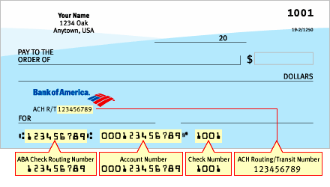

I hereby authorize the Auburn School District to make reimbursement deposits into my bank account, as indicated above. This authority is to remain in full force and effect with the Auburn School District until rescinded in writing.

Signature Date

**Please return this form to:**

**Auburn School District**

**ATTN: Debra Podesta**

**915 4th St NE**

**Auburn, WA 98002**